<Title>
<Subtitle>

<Author>
<Matriculation Number>

Master Thesis Proposal

September 29, 2025
<Supervisor>
<Second supervisor>
Master of Science in Business Information Systems

Statement of Authenticity
I confirm that this master thesis research was performed autonomously by myself using only the sources, aids and assistance stated in the report, and that quotes are readily identifiable as such.

__________________________________________
Date, first name and name

Abstract
Lorem ipsum dolor sit amet, consetetur sadipscing elitr, sed diam nonumy eirmod tempor invidunt ut labore et dolore magna aliquyam erat, sed diam voluptua. At vero eos et accusam et justo duo dolores et ea rebum. Stet clita kasd gubergren, no sea takimata sanctus est Lorem ipsum dolor sit amet. Lorem ipsum dolor sit amet, consetetur sadipscing elitr, sed diam nonumy eirmod tempor invidunt ut labore et dolore magna aliquyam erat, sed diam voluptua. At vero eos et accusam et justo duo dolores et ea rebum. Stet clita kasd gubergren, no sea takimata sanctus est Lorem ipsum dolor sit amet.

Table of Contents
Statement of Authenticity I
Abstract II
Foreword / Acknowledgements (optional) III
Table of Contents IV
1 Introduction 1
2 Literature Review 2
3 Research Method 4
4 … 5
4.1 Section 5
4.1.1 Subsection 5
5 List items 7
6 Labels 8
7 Conclusion 10
Bibliography 11
Abbreviations 12
List of Figures / Tables 13
Figures 14
Tables 15
Appendix / Appendices 16

Introduction
The proposal must describe the problem statement, analysis of the causes and evidence base of the proposed measure(s) and methods.

This chapter contains a research problem statement, the thesis statement and the research questions.

The introduction of a Master’s thesis first sets the stage for the study. A student typically uses it to explain the broader context of the research problem—why the topic matters, what is already known about it, and where the gaps or challenges lie. It usually covers:

The real-world problem or situation that makes the research necessary (such as challenges in system adoption, data integration, or decision-making).

Key trends, practices, or debates in the area (like digital transformation, cloud systems, or AI-driven analytics).

A link to the research focus, showing how the study fits into this bigger picture.
The tone is narrative and explanatory, not yet detailed analysis. Think of it as a bridge: it takes the reader from the general world of the topic down to the specific research problem your study will tackle.
Lorem ipsum dolor …

Problem Statement
The problem statement should describe the problem that the thesis is going to address, point to the gap that exists in the literature (which is conducted in the literature section in more detail). Describe the impact of the problem and when and where the problem is evident. Mention the cause of the problem and specify the relevance of the problem. Specify how the local problem (of your company) relates to a wider research debate.
Do not focus on more than one topic within one thesis!
Lorem ipsum ….

Thesis Statement, Research Questions and Objectives
The thesis statement should be …
- a single thesis statement that a reasonable person in your field could agree or disagree with
- an unambiguous assertion
- worthwhile (= relevant)
- limited in scope
- feasible regarding primary sources (i.e. can you get the data that supports your thesis statement?)
- based on existing theory
- doable in a reasonable amount of time
- testable by you
- within your area of interest/in synergy with career goals
The answers to the research questions lead to a validation of the thesis statement. Each question corresponds to a step in your research design. It should work out a particular aspect which is based on the problem statement.
Lorem ipsum
Research Question | Research Objectives

Delineations and Limitations
Delineations define the boundaries of a study by stating clearly what will and will not be covered, while limitations point to the constraints—such as data, resources, or methods—that could affect the scope or reliability of the findings.
For example, in a Business Information Systems study, the research may be delineated to focus only on the adoption of enterprise resource planning (ERP) systems in medium-sized financial institutions, excluding micro-enterprises and multinational banks. A limitation, however, is that the data is drawn from surveys conducted within a six-month period, which restricts the ability to capture longer-term adoption trends and therefore reduces the generalisability of the results.

Assumptions
In Chapter 1, assumptions are the conditions you take as true for the purpose of your study, even though you cannot fully control or verify them. They are not tested within your research but are necessary to move forward with your investigation. Assumptions often relate to how participants will respond, how data will be interpreted, or how technologies will behave under normal circumstances.
For example, in a Business Information Systems study on ERP adoption, an assumption might be that participants who complete the survey answer honestly and understand the questions as intended. You cannot control how truthful or attentive respondents are, but your findings depend on assuming their responses reflect their real experiences.

Significance

The significance section of Chapter 1 explains why the research is worth doing and what value it brings. It answers the “so what?” question by showing the contribution your work will make. This is usually divided into theoretical significance (how the study adds to or refines academic knowledge and theory) and practical significance (how the results will be useful in solving real-world problems or guiding practice).

Example (Business Information Systems)
The significance of this study lies in both its theoretical and practical contributions. Theoretically, it adds to the body of knowledge on Business Information Systems by exploring how enterprise systems are adopted in medium-sized financial institutions, offering refinements to existing technology adoption frameworks. Practically, the findings provide actionable insights for managers and IT leaders, helping them design better strategies for system implementation, reduce adoption risks, and improve organisational efficiency through more effective use of information systems.

Chapter Map

A chapter map in Chapter 1 is like a roadmap for your thesis.
Its purpose is to give the reader a clear overview of how the rest of the document is structured and what to expect in each chapter.
By briefly describing the focus of every chapter, it helps the reader understand the logical flow of your research—from introduction and literature review, through methodology and results, to discussion and conclusion.

Chapter 1: Introduction
This chapter introduces the research problem, background, objectives, research questions, and significance of the study. It also sets out the assumptions, limitations, delineations, and provides a chapter map.

Chapter 2: Literature Review
This chapter reviews existing theories, models, and studies relevant to Business Information Systems. It identifies gaps in the current body of knowledge and establishes the theoretical framework that underpins the study.

Chapter 3: Research Methodology
This chapter outlines the research design, approach, and methods used to collect and analyse data. It explains why the chosen methods are appropriate for addressing the research questions and achieving the objectives.

Chapter 4: Results / Findings
This chapter presents the results of the study, including data analysis and key findings. The findings are structured around the research questions and linked back to the theoretical framework.

Chapter 5: Discussion and Conclusion
This chapter interprets the findings, discusses their implications in theory and practice, and relates them to existing literature. It also outlines the limitations of the study, recommendations for practice, and suggestions for future research.

Also give your Thesis Chapter map in Graphic Form:

For Example:
Chapter 1: Introduction
Research Question 1
Research Question 2
Research Question 3
Research Question 4

Literature Review
The literature review shows the related work that has been done in the area of the research problem and leads to the recognition of a research gap. It is a series of connected arguments in support of the research questions. Literature should be relevant and point to the state of the art. References should be made to primary, original literature. If the topic is so innovative that literature can hardly be found, the student should explain his/her alternative way of getting information.
Start your Chapter with a Mind Map of the Literature Review, for example
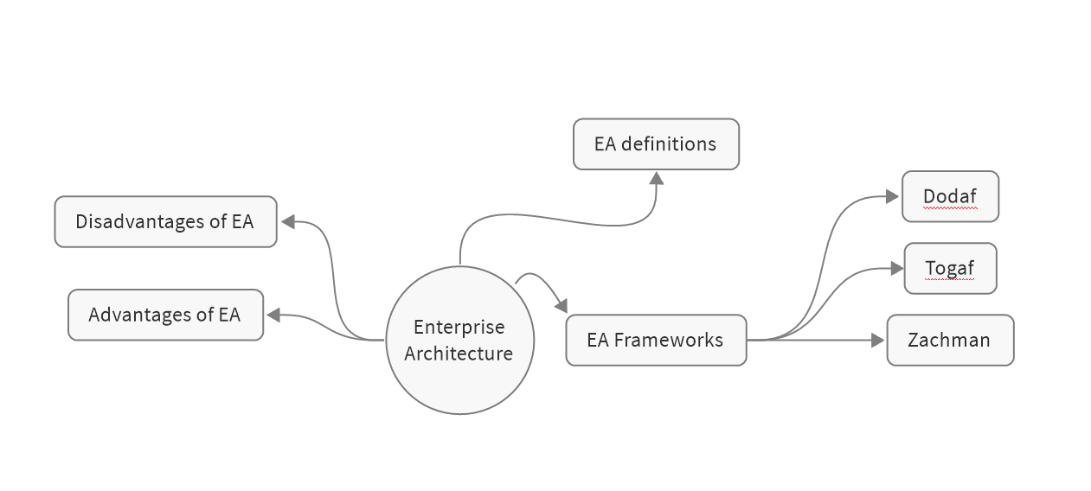

Research Design
The purpose of this chapter is to describe your intended research design and convince the reader that YOUR research design is appropriate to answer the research questions and so the thesis statement. You should refer to a standard, sound research strategy and apply it to your research problem. There should be a discussion of alternative approaches including strengths and weaknesses, but it is not necessary to describe all research philosophies, approaches and strategies in detail (do not repeat and re-describe the research onion).
You may have two sub-sections concerning YOUR “3.x Research Methods, Strategy and Choice” and “3.x Data Collection, Sources and Analysis”.
Break down work into tasks/work packages. Which steps do you do and what do you do in these steps? What information/data do you need and why? How do you plan to collect and analyze the data?
Estimate work time needed for tasks and specify your milestones. Identify risks, bottlenecks and dependencies from the input of others.
Include the table with ONLY YOUR OWN CHOICES (don’t include all the choices).
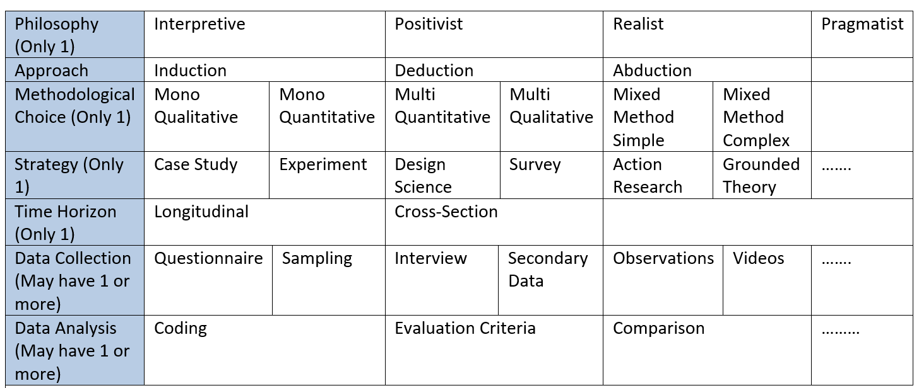
Example:
Philosophy (Only 1) | Interpretive
Approach | Induction
Methodological Choice (Only 1) | Mono Qualitative
Strategy (Only 1) | Case Study
Time Horizon (Only 1) | Cross-Section
Data Collection (May have 1 or more) | Interview
Data Analysis (May have 1 or more) | Coding

For Example - Discuss each choice:
  - Philosophy: My philosophical stance for this research was xxx because
3.2 Approach: I followed an xxxx approach because
3.3 Methodological Approach: My methodological choice was xxx because …
3.4 Strategy: My strategy was cccc research since the focus was on a single business where the purpose was to understand …
3.5 Time Horizon: The time horizon was cross sectional since in the study the time was only for a period between January 2026 and March 2026
3.6 Example - Data Collection: For data collection interviews was used with open-ended questions. The following questions were guiding questions:
Question | Purpose of the question

Lorem ipsum dolor sit amet, consetetur sadipscing elitr, sed diam nonumy eirmod tempor invidunt ut labore et dolore magna aliquyam erat, sed diam voluptua. At vero eos et accusam et justo duo dolores et ea rebum. Stet clita kasd gubergren, no sea takimata sanctus est Lorem ipsum dolor sit amet. Lorem ipsum dolor sit amet, consetetur sadipscing elitr, sed diam nonumy eirmod tempor invidunt ut labore et dolore magna aliquyam erat, sed diam voluptua.

Section
Lorem ipsum dolor sit amet, consetetur sadipscing elitr, sed diam nonumy eirmod tempor invidunt ut labore et dolore magna aliquyam erat, sed diam voluptua. At vero eos et accusam et justo duo dolores et ea rebum. Stet clita kasd gubergren, no sea takimata sanctus est Lorem ipsum dolor sit amet. Lorem ipsum dolor sit amet, consetetur sadipscing elitr, sed diam nonumy eirmod tempor invidunt ut labore et dolore magna aliquyam erat, sed diam voluptua.
Lorem ipsum dolor sit amet, consetetur sadipscing elitr, sed diam nonumy eirmod tempor invidunt ut labore et dolore magna aliquyam erat, sed diam voluptua. At vero eos et accusam et justo duo dolores et ea rebum. Stet clita kasd gubergren, no sea takimata sanctus est Lorem ipsum dolor sit amet

Subsection
Stet clita kasd gubergren, no sea takimata sanctus est Lorem ipsum dolor sit amet. Lorem ipsum dolor sit amet, consetetur sadipscing elitr, sed diam nonumy eirmod tempor invidunt ut labore et dolore magna aliquyam erat, sed diam voluptua.

List items
Ordered lists:
- Text
- Text
- Text
- Text
- Text
- Text
- Text
- Text
- Text
- Text
- Text
- Text

Unordered lists:
- Text
- Text
- Text

Figure and Table Captions
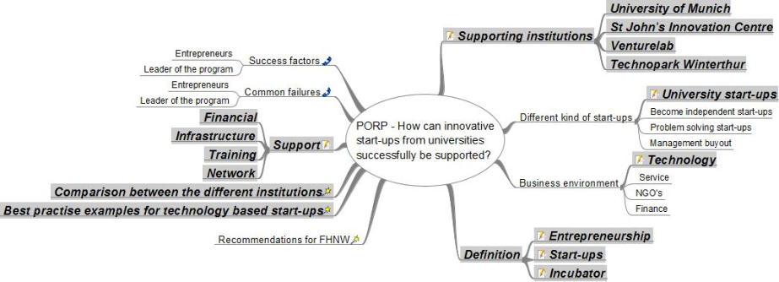
Figure 1: Mind map of PORP.

Table 1: Advantages and disadvantages of start-ups
Advantages | Disadvantages
Freedom of the owner to decide how to operate and what the business does | A lot of uncertainties are involved
The owner can decide what has to be done | The probability that a start-up will fail is high
Business can build up from scratch without any backlog of problems | The start-up is not well known, the reputation has to be build up first
Governmental support or assistance of certain institution | Barrier of market entry might be high
No franchising fee or acquisition costs are required | Difficult to find investors, due to the high uncertainties
Mind the formatting within the table.

Conclusion
Lorem ipsum dolor sit amet, consetetur sadipscing elitr, sed diam nonumy eirmod tempor invidunt ut labore et dolore magna aliquyam erat, sed diam voluptua. At vero eos et accusam et justo duo dolores et ea rebum. Stet clita kasd gubergren, no sea takimata sanctus est Lorem ipsum dolor sit amet. Lorem ipsum dolor sit amet, consetetur sadipscing elitr, sed diam nonumy eirmod tempor invidunt ut labore et dolore magna aliquyam erat, sed diam voluptua. At vero eos et accusam et justo duo dolores et ea rebum. Stet clita kasd gubergren, no sea takimata sanctus est Lorem ipsum dolor sit amet.
Lorem ipsum dolor sit amet, consetetur sadipscing elitr, sed diam nonumy eirmod tempor invidunt ut labore et dolore magna aliquyam erat, sed diam voluptua. At vero eos et accusam et justo duo dolores et ea rebum. Stet clita kasd gubergren, no sea takimata sanctus est Lorem ipsum dolor sit amet

Bibliography

Abbreviations (optional)

Figures
Figure 1: Mind map of PORP. 2

Tables
Table 1: Advantages and disadvantages of start-ups 2

Appendix / Appendices

